

**ART BLOCKS**

**MINOR PROJECT - II**

**Submitted in Partial Fulfilment of the Requirements for the Award of the Degree of**

**MASTER OF COMPUTER APPLICATIONS**

**(M.C.A.)**

**BY**

**Urvashi Rajpal (35111604422)**

**MCA – 2nd SEMESTER**



**BHARATI VIDYAPEETH’S INSTITUTE OF COMPUTER APPLICATIONS AND MANAGEMENT (BVICAM)**

**(GURU GOBIND SINGH INDRAPRASTHA UNIVERSITY)**

**NEW DELHI**

**July, 20****23**

**CANDIDATE’S DECLARATION**

I hereby declare that the work which is being presented in this project work entitled “**Art Blocks**” in partial fulfilment of the requirements for the award of the degree of **Master in Computer Applications at Bharati Vidyapeeth’s Institute of Computer Applications and Management (BVICAM), New Delhi** is an authentic record of my own work carried out during the period March 2023 to July 2023 under the supervision and guidance of **Dr. Sunil Pratap Singh(Associate Professor, BVICAM)**.

I have not submitted the matter embodied in this project work anywhere for the award of any degree or diploma.

**Urvashi Rajpal**

**MCA 2nd Semester**

**35111604422**

**ACKNOWLEDGEMENT**

It is my proud privilege to express my profound gratitude to the entire management of Bharati Vidyapeeth’s Institute of Computer Applications and Management and teachers of the institute for providing me with the opportunity to avail the excellent facilities and infrastructure. The knowledge and values inculcated have proved to be of immense help at the very start of my career. Special thanks to Hon’ble Founder, Bharati Vidyapeeth, Pune for having provided us an excellent infrastructure at BVICAM.

I am grateful to **Dr. Sunil Pratap Singh & Dr. Vaishali Joshi**(Project Guide, BVICAM, New Delhi) for his astute guidance, constant encouragement and sincere support for this project work.

I feel pride and privileged in expressing my deep sense of gratitude to all those who have helped me in presenting my MCA PROJECT, **Art Blocks**. I would be failing in my endeavour if I do not place my acknowledgement**.**

**ABSTRACT**

In this minor project, we have developed an NFT project which aims to delve into the world of non-fungible tokens (NFTs) and their transformative impact on digital asset ownership. NFTs have revolutionized the way we perceive and exchange digital assets by providing unique, verifiable, and immutable records of ownership on blockchain technology. It is built to leverage blockchain technology to tokenize and represent unique assets, creating a secure and transparent system for buying, selling, and trading digital assets. The application is developed using ReactJs, TailwindCSS as front-end technologies and NodeJS, NPM, MetaMask to futher support it for backend. ThirdWeb is used to manage the database for the application. The development of application is carried out by following the agile model of software development. There are mainly 4 modules of the system: connect wallet module, listing NFTs module, purchasing NFTs module and dashboard module.

**TABLE OF CONTENTS**

|  |  |  |
| --- | --- | --- |
|  | | **Page No.** |
| **CHAPTER 1: INTRODUCTION** | | |
| 1.1 | Problem Description | 1 |
| 1.2 | Objective | 2 |
| 1.3 | Proposed Solution | 3 |
| 1.4 | Team Structure and Role | 4 |
|  |  |  |
| **CHAPTER 2: PROJECT DESCRIPTION** | | |
| 2.1 | System Specification | 5 |
|  | 2.1.1 Hardware Requirements | 5 |
|  | 2.1.2 Software Requirements | 5 |
|  | 2.1.3 Technologies Used | 6 |
| 2.2 | Modules and their Descriptions | 7 |
|  |  |  |
| **CHAPTER 3: FUNCTIONALITIES** | | |
| 3.1 | Use Case Diagram | 8 |
| 3.2 | Data Flow Diagrams | 9 |
| 3.3 | Entity-Relationship (E-R) Diagram | 11 |
| 3.4 | Screenshots | 12 |
| 3.5 | Testing | 18 |
|  |  |  |
| **CHAPTER 4: CONCLUSION AND FUTURE SCOPE**  4.1 Conclusion 19 | | |

4.2 Future Scope 19

**CHAPTER 1: INTRODUCTION**

* 1. **PROBLEM DESCRIPTION**

NFT stands for “Non Fungible token”. A nft is a unique token that is used to identify, view and track the ownership of a unique asset either digital or physical. NFTs are basically used to represent various resources such as a work of art, a book, a music record, etc. any object which is considered unique. NFTs are created, minted and stored on a blockchain.

Online marketplaces for digital assets are the recent talk of the fintech town. But, of course, you have to build your own marketplace if you are planning to set foot in the digital market. The words cryptocurrency trading and blockchain technology are no longer unknown, and many people trade goods on several marketplaces.

Our platform makes it simple to store and sell NFTs. The tokens are generally available for purchase or auction at a set price. To use an NFT marketplace, you will need a crypto wallet(Metamask wallet is used which is one of the most popular ethereum wallets) to store and trade your best NFT tokens. Wallet will generate an address for the transaction and when the address is available the transaction can be done for any NFT available on any site. No personal information is required to mention transactions are done only with the wallet address.

Ultimately, this research project seeks to provide insights into the disruptive potential of NFTs and their implications for digital asset ownership, creativity, and value exchange. By understanding the intricacies of NFTs and their applications, we can navigate the evolving landscape of the digital economy and contribute to the advancement of this groundbreaking technology.

Users have to create an account, upload digital artworks, and sell their work on the marketplace. In general, specialized marketplaces are more popular than conventional ones because they include everything a client would require—specialized marketplaces expertise in promoting online artworks and concentrating on specific target audiences.

The world of non-fungible tokens (NFTs) has seen the rise of several popular and influential collections. Among these, CryptoPunks stands as one of the earliest and most iconic NFT projects, featuring 10,000 unique pixel art characters that hold historical significance within the NFT space.

**1.2 OBJECTIVE**

The primary objective of our NFT marketplace project is to provide a robust and inclusive platform for the NFT community.

* We aim to deliver an intuitive and visually appealing user interface that ensures a seamless browsing, buying, and selling experience.
* Building trust within the marketplace is crucial. We will implement measures to ensure the authenticity and provenance of NFTs listed on our platform. By incorporating smart contract technology and transparent verification processes, we aim to establish a secure and reliable environment for NFT transactions.
* We recognize the importance of community engagement and social interaction. Our objective is to foster a supportive and interactive community within the marketplace.

The objective of this project is to explore the potential applications and implications of NFTs across various industries, including art, gaming, collectibles, real estate, and more. By analyzing the underlying technology, smart contract functionality, and market trends, we aim to understand the fundamental principles and mechanisms behind NFTs.

**1.3 PROPOSED SOLUTION**

Our proposed solution is to develop a comprehensive and user-centric NFT marketplace that addresses the current challenges and meets the evolving needs of the NFT ecosystem. Our marketplace will provide a seamless and secure platform for users to discover, buy, sell, and trade non-fungible tokens (NFTs) across various industries, including art, collectibles, gaming, and more. The objective of this project is to explore the potential applications and implications of NFTs across various industries, including art, gaming, collectibles, real estate, and more. By analyzing the underlying technology, smart contract functionality, and market trends, we aim to understand the fundamental principles and mechanisms behind NFTs.

The marketplace will prioritize user experience by offering an intuitive and visually appealing interface, allowing users to easily discover, buy, sell, and trade NFTs across various industries. We will prioritize security by leveraging blockchain technology and smart contracts to ensure transparent and secure transactions. Supporting a wide range of NFT asset categories, such as artwork, collectibles, and gaming items, our marketplace will cater to diverse user interests.

We will provide support for creators to mint and list their NFTs, empowering them to showcase their work and monetize their assets. Seamless integration with wallets, blockchains, and DApps will facilitate smooth asset management and interoperability.

Overall, our proposed solution aims to provide a trusted, inclusive, and feature-rich NFT marketplace that caters to user needs and supports the growth of the NFT ecosystem.

**1.4 TEAM STRUCTURE AND ROLE**

Our project consists of a dedicated team with various roles and responsibilities to ensure the successful development and implementation of the NFT marketplace.

* We were involved in collection of information related to my project and explore about blockchain and cryptocurrency.
* We divided our team in three members each having specific modules to cover, connect wallet, list NFTs, purchase NFTs and the dashboard.
* We were responsible for designing and implementing the blockchain infrastructure of the NFT marketplace.
* We were responsible for approving the designing tool and database selection.
* We were responsible for implementing the necessary functionalities, managing data storage, and ensuring seamless communication between the front-end and the blockchain

The team worked collaboratively, leveraging their expertise and skills, to deliver a comprehensive and successful NFT marketplace that aligns with the project's objectives and meets the needs of its users. Regular communication, coordination, and agile project management practices will be key to the team's success.

**CHAPTER 2: PROJECT DESCRIPTION**

**2.1 SYSTEM SPECIFICATION**

**2.1.1 Hardware Requirements:**

* **Processor:** Pentium-4 class processor or Above
* **RAM:** 2GB of RAM or Above
* **Operating System:** Windows XP or Above

**2.1.2 Software Requirements:**

* **Operating System**: Windows, Mac
* **Database Server:** ThirdWeb
* **Client:** Microsoft Internet Explorer or any other web browser.

**2.1.3 Technologies Used:**

* **Front-End:** HTML, TailWind CSS, React
* **Back-End:** ThirdWeb
* MetaMask
* Blockchain

**Visual Studio Code**

Visual Studio Code is a lightweight but powerful source code editor which runs on your desktop and is available for Windows, Mac OS and Linux. It is “a free-editor that helps the programmer write code, helps in debugging and corrects the code using the intelligence method”. In normal terms, it facilitates users to write the code in an easy manner. Many people say that it is half of an IDE and an editor, but the decision is up to the coders.

It comes with built-in support for JavaScript, Typescript and Node.js and has a rich ecosystem of extensions for other languages.

The most prominent and which supports almost every coding language is VISUAL STUDIO CODE. Its features let the user modify the editor as per the usage, which means the user is able to download the libraries from the internet and integrate it with the code as per his requirements.

[](https://en.wikipedia.org/wiki/File:Visual_Studio_Code_1.35_icon.svg)

**React JS**

React is a JavaScript-based UI development library. Facebook and an open-source developer community run it. Although React is a library rather than a language, it is widely used in web development. The library first appeared in May 2013 and is now one of the most commonly used frontend libraries for web development.

React offers various extensions for entire application architectural support, such as Flux and React Native, beyond mere UI.



**Third-Web**

The Third Web represents a vision for the future evolution of the internet that goes beyond the current state of the web. It embraces emerging technologies like blockchain, artificial intelligence, virtual reality, and decentralized systems to create a more decentralized, secure, and user-centric digital ecosystem.

The terms "Third Web" and "Web 3.0" are often used interchangeably to refer to the next phase of the internet's development. While there is no universally agreed-upon definition, both concepts envision a future iteration of the internet that builds upon the current Web 2.0 and incorporates emerging technologies and principles.

The Third Web or Web 3.0 represents a vision where the internet becomes more decentralized, secure, and user-centric. It seeks to address the limitations of Web 2.0 and explore new possibilities enabled by technologies such as blockchain, decentralized systems, artificial intelligence (AI), and the Internet of Things (IoT). The Third Web emphasizes concepts such as data ownership, privacy, self-sovereign identity, and user empowerment.



**2.2 MODULES**

The following are Project Modules:

* **Connect Wallet**: In this module, user can connect his/her MetaMask wallet with the website.
* **Listing NFT**: In this module, connected user can see all the active NFT listed in Third Web.
* **Purchasing NFT**: In this module, connected user can purchase a NFT which he/she selected.
* **Dashboard**: In this module, connected user can see all the NFT he/she purchased/owned.

**CHAPTER 3: FUNCTIONALITIES**

**3.1 USE CASE DIAGRAM**

A use case diagram is a way to summarize details of a system and the users within that system. It is generally shown as a graphic depiction of interactions among different elements in a system. Use case diagrams will specify the events in a system and how those events flow, however, use case diagram does not describe how those events are implemented.

The purpose of the use case to define a piece of coherent behaviour without revealing the internal structure of the system. A use case typically represents a sequence of interaction between the user and the system. These interactions consist of one main line sequence is represent the normal interaction between the user and the system. The use case model is an important analysis and design artefact (task). Use cases can be represented by drawing a use case diagram and writing an accompany text elaborating the drawing.

**Use case diagram uses:**

* Represent the goals of systems and users.
* Specify the context a system should be viewed in.
* Specify system requirements.
* Provide a model for the flow of events when it comes to user interactions.
* Provide an outside view of a system.
* Show’s external and internal influences on a system.

In the use case diagram, each use case is represented by an ellipse with the name of use case written inside the ellipse. All the ellipses of the system are enclosed with in a rectangle which represents the system boundary. The name of the system being modules appears inside the rectangle. The different users of the system are represented by using stick person icon. The stick person icon is normally referred to as an Actor. The line connecting the actor and the use cases is called the communication relationship.

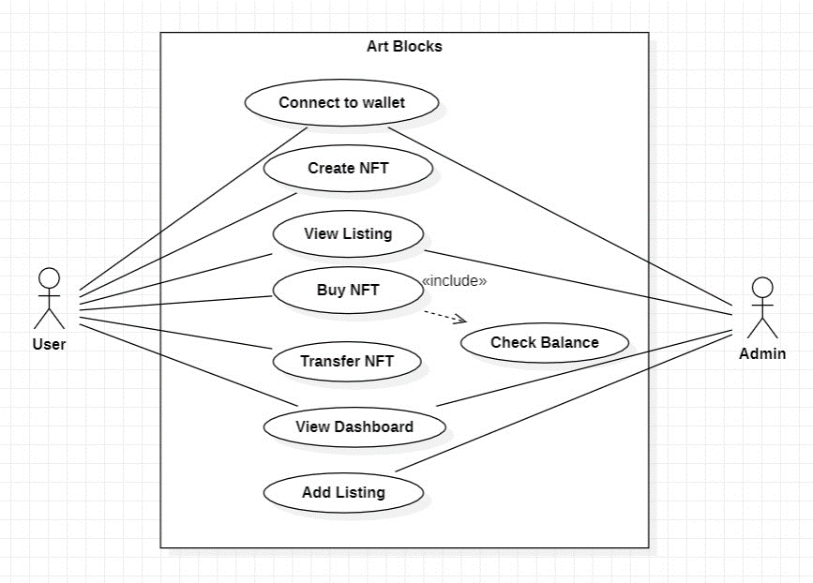

**3.2 DATA FLOW DIAGRAM**

**DFD** is the abbreviation for **Data Flow Diagram**. The flow of data of a system or a process is represented by DFD. It also gives insight into the inputs and outputs of each entity and the process itself. DFD does not have control flow and no loops or decision rules are present.

The objective of a DFD is to show the scope and boundaries of a system as a whole. It may be used as a communication tool between a system analyst and any person who plays a part in the order that acts as a starting point for redesigning a system. The DFD is also called as a data flow graph or bubble chart.

Specific operations depending on the type of data can be explained by a flowchart. Data Flow Diagram can be represented in several ways. The DFD belongs to structured-analysis modelling tools. Data Flow diagrams are very popular because they help us to visualize the major steps and data involved in software-system processes.

The following observations about DFDs are essential:

1. All names should be unique. This makes it easier to refer to elements in the DFD.
2. Remember that DFD is not a flow chart. Arrows is a flow chart that represents the order of events; arrows in DFD represents flowing data. A DFD does not involve any order of events.
3. Suppress logical decisions. If we ever have the urge to draw a diamond-shaped box in a DFD, suppress that urge! A diamond-shaped box is used in flow charts to represents decision points with multiple exists paths of which the only one is taken. This implies an ordering of events, which makes no sense in a DFD.
4. Do not become bogged down with details. Defer error conditions and error handling until the end of the analysis.

* **Levels of DFD**
* 0-LEVEL DFD

A level 0 DFD is called fundamental system model or context model represents entire software element as a single bubble with input and output data indicating by incoming and outgoing arrows. It is also known as fundamental system model, or context diagram represents the entire software requirement as a single bubble with input and output data denoted by incoming and outgoing arrows. Then the system is decomposed and described as a DFD with multiple bubbles.

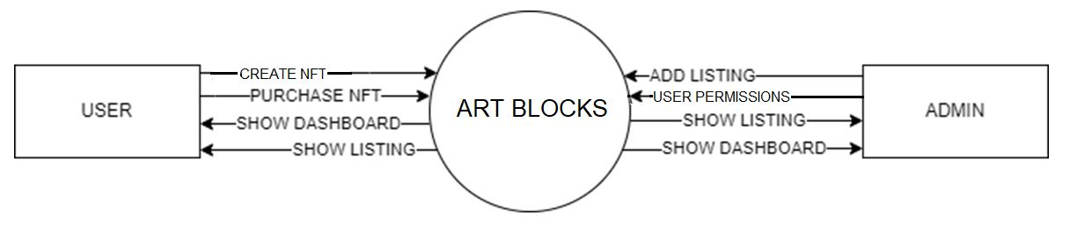

* **DFD-1 (Level 1)**

In 1-level DFD, a context diagram is decomposed into multiple bubbles/processes. In this level, we highlight the main objectives of the system and breakdown the high-level process of 0-level DFD into subprocesses.

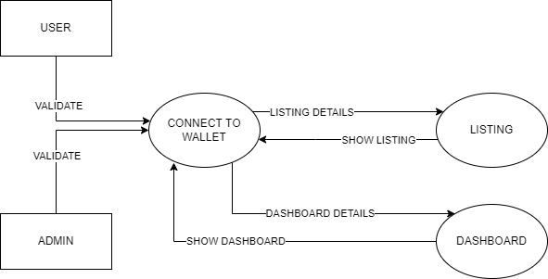

* 1. **ENTITY RELATIONSHIP (E-R) DIAGRAM**

ER-Diagram is a pictorial representation of data that describes how data is communicated and related to each other. Any object, such as entities, attributes of an entity, sets of relationship, and other attributes of relationship, can be characterized with the help of the ER diagram.

An ER Diagram contains entities, attributes, and relationships.

The primary purpose of the ERD is to represent data objects and their relationship. It is a detailed logical representation of data for an organization and uses three main constructs.

**LIST OF SYMBOLS**

|  |  |  |
| --- | --- | --- |
| **ENTITY SYMBOL** | **NAME** | **DESCRIPTION** |
|  | Relationship | Relationships are associations between or among entities |
| https://images.visual-paradigm.com/docs/vp_user_guide/11/94/2575/2745/uml_use_case_icon_19877.png | [Use Case](https://www.visual-paradigm.com/support/documents/vpuserguide/94/2575/84257_usecasediagr.html#uml-use-case) | Horizontally shaped ovals that represent the different uses that a user might have |
| https://images.visual-paradigm.com/docs/vp_user_guide/11/94/2575/2745/uml_association_icon_19878.png | Association | A line between actors and use cases. In complex diagrams, it is important to know which actors are associated with which use cases. |
| https://images.visual-paradigm.com/docs/vp_user_guide/11/94/2575/2745/uml_actor_icon_19879.png | [Actor](https://www.visual-paradigm.com/support/documents/vpuserguide/94/2575/84257_usecasediagr.html#uml-actor) | Stick figures that represent the people actually employing the use cases. |
| https://images.visual-paradigm.com/docs/vp_user_guide/11/94/2575/2745/uml_system_icon_19880.png | System | A specific sequence of actions and interactions between actors and the system. A system may also be referred to as a scenario. |
|  | Data Flow | Movement of data between external entities, processes and data stores is represented with an arrow symbol, which indicates the direction of flow. |
|  | Process | An activity that changes or transforms data flows. Since they transform incoming data to outgoing data, all processes must have inputs and outputs  on a DFD |
| Entity - ERD Symbol | Entity | Also known as actors, sources or sinks, and terminators, external entities produce and consume data that flows between the entity and the system being diagrammed. |
| Attribute - ERD Symbol | Attribute | Attributes are characteristics of an entity, a many-to-many relationship, or a one-to-one relationship |
|  | Data Store | A data store does not generate any operations but simply holds data for later access |

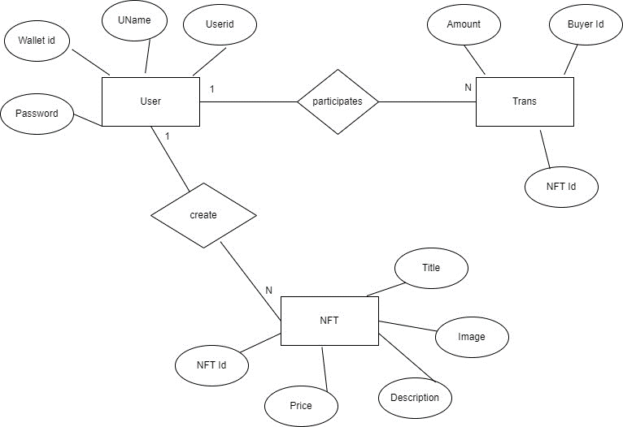

**3.4 SCREENSHOTS**

**3.5 TESTING**

**3.5.1 INTRODUCTION**

Executing a program with the intent of finding errors is called testing. Testing is vital to the success of any system. Testing is done at different stages within the development phase. System testing makes a logical assumption that if all parts of the system are correct, the goals will be achieved successfully. Inadequate testing or no testing at all leads to errors that may come up after a long time when correction would be extremely implementation. The testing of the system was done on both artificial and live data. In order to test data test cases are developed.

3.5.2 TEST PLANS

The test strategy implementation of the project that defines how the testing has been carried out. We followed the Reactive approach to testing. This means that we continued testing each component or module of our project during its creation. However, we are only able to test it completely once the coding and designing part of the project is complete. The testing methodologies in the development process which make sure that the software can successfully operate in multiple environments and across different platforms. We are trying to develop a project which will work on the web and as a mobile application. This will help the end-users to access the platform with ease and flexibility. Also, the offline mode is available for users to access the network anywhere and anytime.

* WHITE BOX TESTING

It is a testing approach in which internal structure is known to the tester. It is best suited for a lower level of testing like Unit Testing, Integration testing. White box testing is usually done by testers and developers. It is a structural test of the software. As developers, we realised that testing through the white-box testing procedure is more feasible than black-box testing because we developed the code and therefore have all the knowledge about the internal structure. The features of white-box testing are in favour of the developers. However, when we learn about other kinds of testing such as non-functional testing, we realise that it is also possible to state some information and facts about them based on our project.

* Unit Testing

Unit testing is the first level of testing which ensures that the individual components of a piece of software at the code level are functional and work as they were designed. The unit testing was done during the development of the specific components of each module by an individual. This was conducted manually by repeatedly debugging the errors for the proper functionality of the module components. We typically wrote and aimed to execute the tests prior to the software being deployed in front of the evaluators or testers. This testing helped us debug the code at an early stage so that we don’t find errors when we combine all the components of the module together. E.g., Creation and testing of the login page and forgot password page.

* Functional Testing

This testing is based on the requirements specified by various stakeholders and incorporates testing to ensure that all the components are working properly.

* Integrating Testing

Integration testing is the next step after unit testing. These are then tested as a group through integration testing to ensure whole segments of an application behave as expected. Once all the components were tested, we began combining those components into one module. Manual tests were also conducted for integration. This test enabled us to run all the components one after the other smoothly. For e.g., creation and testing of the homepage and the subpages individually and then combining it to test it for proper functionality.

* SYSTEM TESTING

It is executing programs to check logical changes made in it with intention of finding errors. a system is tested for online response, volume of transaction, recovery from failure etc. System testing is done to ensure that the system satisfies all the user requirements.

**3.5.3 TEST CASES**

|  |  |  |  |  |
| --- | --- | --- | --- | --- |
| **S.No.** | **Module Name** | **Test Case No** | **Test Case Description** | **Expected Result** |
| 1 | Connect to Wallet | TC1 | To make sure that the system work, user must connect to wallet | Wallet Connected Successfully |
| 2 | Purchase | TC2 | To assure that user can purchase NFT, they must have ETH. | Purchase Successfully |
| 3 | Tranfer | TC3 | Verify and check wallet id | NFT successfully transfered |
| 4 | Create NFT | TC4 | NFT Details like title, description should be mentioned | NFT uploaded successfully |

**CHAPTER 4: CONCLUSION & FUTURE SCOPE**

**4.1 Conclusion**

NFT marketplaces are yet to see their peak. With the digital versions of different art forms, collectibles, creative assets, and even from the physical world are making waves, the NFT marketplace is a business worth pursuing.

As more people will create, buy, and sell, the popularity of a secure and reliable NFT marketplace will only enhance. The domain is popular but not overcrowded as of now. This presents you with a perfect opportunity and time to launch your own NFT marketplace.

**4.2 Future Scope**

Indeed, the world is changing fast. It is moving away from old- conventional ways of transaction to digitally advanced wallets that make space for both money and crypto currencies. With so many raging possibilities, it’s important to understand the differences between the various types of currencies. **Digital currency is government- issued electronic form of money.**

**Crypto currency**, on the other hand, is a virtual currency created by a private system. It is decentralised, is not governed by any government, and is based on block chain technology. Non-fungible Tokens, or NFTs, are digital assets that represent real-world objects like music, art, **memes**, fashion, and so on.

1. Partnership Collaborations: We can explore partnerships and collaborations with artists, game developers, and other stakeholders in the NFT ecosystem. By forming strategic alliances, we can expand our asset offerings, attract a wider user base, and tap into new markets.
2. Enhanced Marketplace Features: We can continuously enhance our marketplace by introducing new features and functionalities. This may include improved search and discovery mechanisms, advanced trading options, gamification elements, and integration with emerging technologies such as virtual reality or augmented reality.
3. NFT Fractionalization: We can explore the concept of fractionalizing NFTs, allowing users to own fractional shares of high-value assets. This opens up opportunities for broader participation and investment in premium NFTs that may otherwise be financially out of reach for some collectors.
4. Cross-Chain Interoperability: With the growing adoption of multiple blockchain networks, we can consider enabling cross-chain interoperability. This would allow NFTs to move seamlessly between different blockchains, expanding liquidity and accessibility for users.
5. Community and Social Features: We can further foster community engagement within our NFT project by enhancing social features, facilitating user collaborations, and hosting virtual events or auctions. This would create a thriving community of artists, collectors, and enthusiasts, enhancing the overall user experience.

**REFERENCES**

* <https://reactjs.org/docs/getting-started.html>
* <https://reactrouter.com/docs/en/v6/getting-started/overview>
* <https://tailwindcss.com/docs/installation>
* <https://thirdweb.com/dashboard/programs>
* <https://metamask.io/>
* <https://sepoliafaucet.com/>
* React In Action by: Mark Tielens Thomas